**What’s next?**

BHM – Significant events – Year 3 – An introduction to Black History Month

**Year 1**

**History Topic: BHM – Mae C Jemison**

**Seamer and Irton CP School – Knowledge Organiser**

**Prior Knowledge**

EYFS – Understanding the World: Past and present

Know some similarities and differences between things in the past and now, drawing on their experiences and what has been read in class;

Understand the past through settings, characters and events encountered in books read in class and storytelling.

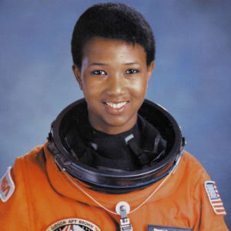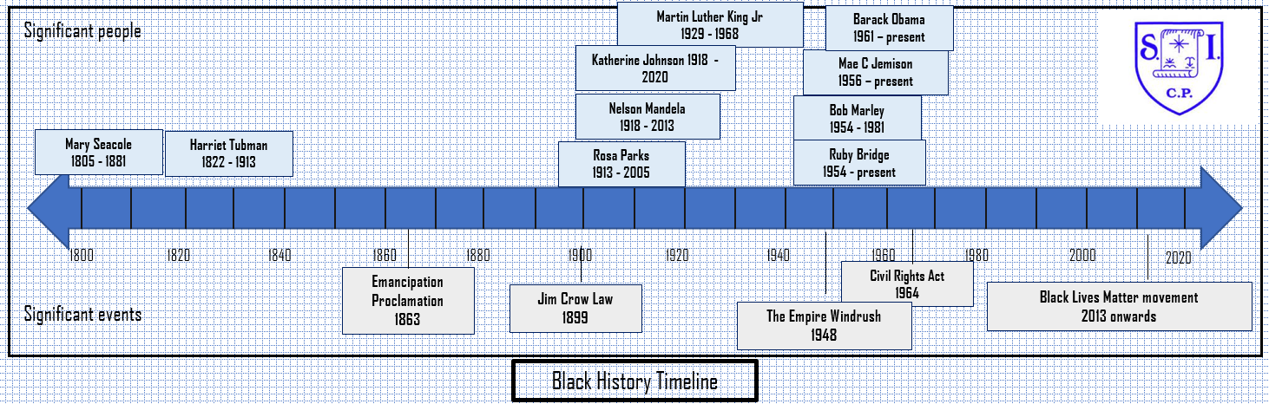

**How I will show what I have learned?**

I can explore the life of Jemison

I understand Jemison’s achievements are significant as the first black, female astronaut

I can discuss how and why we should remember the achievements of Jemison

I can research information about similar black women working for NASA

I can present the information I have learned about Jemison’s achievements

**Key vocabulary I need to know**

Astronaut

Endeavour

Explorer

NASA

[Specialist](https://www.vocabulary.com/dictionary/specialist)

**Key Knowledge I need to understand**

Mae Jemison (born on October 17 1956) was the first African American woman to become an astronaut. She was a part of the crew of the space shuttle Endeavour, which orbited Earth for more than a week in 1992

Katherine Johnson (1918 – 2020) was an American [mathematician](https://kids.britannica.com/kids/article/mathematics/353443). She made important contributions to the United States [space program](https://kids.britannica.com/kids/article/space-exploration/353794#253796-toc) during her career at the [National Aeronautics and Space Administration](https://kids.britannica.com/kids/article/National-Aeronautics-and-Space-Administration/628948) (NASA). Her work helped send astronauts to the Moon.

Mary Jackson (1921 – 2005) was a mathematician and aerospace engineer. In 1951 she joined the West Computers at the National Advisory Committee for Aeronautics, and in 1958 she became the first black female engineer at NASA.